**Laporan Praktikum Modul 4**

**Bahasa Pemograman 1**

**Dosen pengampu : Dede Husen, M.Kom.**



**Nama : Bayu Imantoro**

**NIM : 20230810089**

**Kelas : TINFC – 2023 – 04**

**Teknik Informatika**

**Fakultas Ilmu Komputer**

**Universitas Kuningan**

PRETEST

1. Apakah komponen AWT dan Swing dapat digunakan untuk membuat animasi 2D dan 3D?

* Komponen **AWT** dan **Swing** dapat digunakan untuk membuat animasi 2D sederhana menggunakan kelas seperti Graphics dan Graphics2D. Namun, untuk animasi 3D, AWT dan Swing tidak ideal karena tidak memiliki dukungan bawaan untuk rendering 3D. Sebagai gantinya, Java menyediakan pustaka seperti **JavaFX** atau **JOGL** (Java OpenGL) untuk animasi 3D yang lebih kompleks dan efisien.

1. Buat program untuk penerapan jawaban NO.1 tersebut dalam java?

* import javax.swing.*;

import java.awt.*;

public class AnimasiSederhana extends JPanel {

private int x = 0; // Posisi horizontal

private int deltaX = 5; // Kecepatan gerak

public AnimasiSederhana() {

Timer timer = new Timer(30, e -> {

x += deltaX; // Gerakkan lingkaran

if (x <= 0 || x >= getWidth() - 50) deltaX = -deltaX; // Pantul

repaint(); // Perbarui tampilan

});

timer.start();

}

@Override

protected void paintComponent(Graphics g) {

super.paintComponent(g);

g.setColor(Color.RED);

g.fillOval(x, 100, 50, 50); // Gambar lingkaran

}

public static void main(String[] args) {

JFrame frame = new JFrame("Animasi 2D");

frame.add(new AnimasiSederhana());

frame.setSize(400, 300);

frame.setDefaultCloseOperation(JFrame.EXIT_ON_CLOSE);

frame.setVisible(true);

}

}

PRAKTIKUM

1. Tuliskan source code berikut :

Source code :

/*

* Click nbfs://nbhost/SystemFileSystem/Templates/Licenses/license-default.txt to change this license

* Click nbfs://nbhost/SystemFileSystem/Templates/Classes/Class.java to edit this template

*/

/**

*

* @author Fujitsu U938

*/

import java.awt.Color;

import java.awt.Dimension;

import java.awt.Graphics;

import java.awt.event.ActionEvent;

import java.awt.event.ActionListener;

import java.util.ArrayList;

import java.util.List;

import javax.swing.JFrame;

import javax.swing.JPanel;

import javax.swing.SwingUtilities;

import javax.swing.Timer;

public class BP1_P1_M5 extends JPanel {

private static final int L = 400, T = 400;

List<Mobil> mobil1;

public BP1_P1_M5() {

setBackground(new Color(0, 0, 0));

setLayout(null);

mobil1 = new ArrayList();

mobil1.add(new Mobil(100, 200));

Timer timer = new Timer(50, new ActionListener(){

@Override

public void actionPerformed(ActionEvent e) {

for (Mobil mobil : mobil1) {

mobil.Bergerak();

repaint();

}

}

});

timer.start();

}

protected void paintComponent(Graphics g) {

super.paintComponent(g);

for (Mobil mobil : mobil1)

{ mobil.GambarMobil(g);}

}

public Dimension getPreferredSize() {

return new Dimension(L, T);

}

public class Mobil {

private static final int INCREMENT = 5;

int x, y;

public Mobil(int x, int y) {

this.x = x;

this.y = y;

}

public void GambarMobil(Graphics g){

g.setColor(Color.BLUE);

g.fillRect(x + 15, y - 12, 60, 35);

g.setColor(Color.yellow);

g.fillRect(x, y, 110, 30);

g.setColor(Color.red);

g.fillOval(x + 15, y + 20, 20, 20);

g.fillOval(x + 60, y + 20, 20, 20);

}

public void Bergerak() {

if (x == L) {

x = 1;

} else {

x += INCREMENT;

}

}

}

public static void main(String[] args) {

SwingUtilities.invokeLater(new Runnable() {

public void run() {

JFrame frame = new JFrame();

frame.getContentPane().add(new BP1_P1_M5());

frame.setDefaultCloseOperation(JFrame.EXIT_ON_CLOSE);

frame.setTitle("Animasi Mobil Bergerak");

frame.pack();

frame.setLocationRelativeTo(null);

frame.setVisible(true);

}

});

}

}

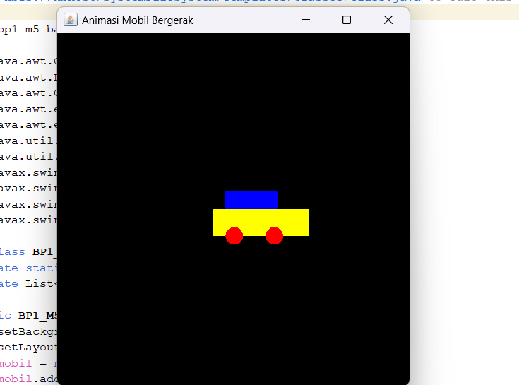

POSTEST

/*

* Click nbfs://nbhost/SystemFileSystem/Templates/Licenses/license-default.txt to change this license

* Click nbfs://nbhost/SystemFileSystem/Templates/Classes/Class.java to edit this template

*/

package bp1_m5_bayu;

import java.awt.Color;

import java.awt.Dimension;

import java.awt.Graphics;

import java.awt.event.ActionEvent;

import java.awt.event.ActionListener;

import java.util.ArrayList;

import java.util.List;

import javax.swing.JFrame;

import javax.swing.JPanel;

import javax.swing.SwingUtilities;

import javax.swing.Timer;

public class BP1_M5_PostTest_Bayu extends JPanel {

private static final int L = 400, T = 400;

private List<Bola> bola;

public BP1_M5_PostTest_Bayu() {

setBackground(Color.BLACK);

setLayout(null);

bola = new ArrayList<>();

bola.add(new Bola(200, 0));

Timer timer = new Timer(50, new ActionListener() {

@Override

public void actionPerformed(ActionEvent e) {

for (Bola b : bola) {

b.Bergerak();

}

repaint();

}

});

timer.start();

}

@Override

protected void paintComponent(Graphics g) {

super.paintComponent(g);

for (Bola b : bola) {

b.GambarBola(g);

}

}

@Override

public Dimension getPreferredSize() {

return new Dimension(L, T);

}

private static class Bola {

private static final int INCREMENT = 8; //kecepatan bola

private int x, y;

private static final int DIAMETER = 100; //ddiameter bola

public Bola(int x, int y) {

this.x = x;

this.y = y;

}

public void GambarBola(Graphics g) {

g.setColor(Color.BLUE);

g.fillOval(x, y, DIAMETER, DIAMETER);

}

public void Bergerak() {

if (y >= T) {

y = -DIAMETER;

} else {

y += INCREMENT;

}

}

}

public static void main(String[] args) {

SwingUtilities.invokeLater(new Runnable() {

@Override

public void run() {

JFrame frame = new JFrame("Animasi Bola Bergerak");

frame.getContentPane().add(new BP1_M5_PostTest_Bayu());

frame.setDefaultCloseOperation(JFrame.EXIT_ON_CLOSE);

frame.pack();

frame.setLocationRelativeTo(null);

frame.setVisible(true);

}

});

}

}

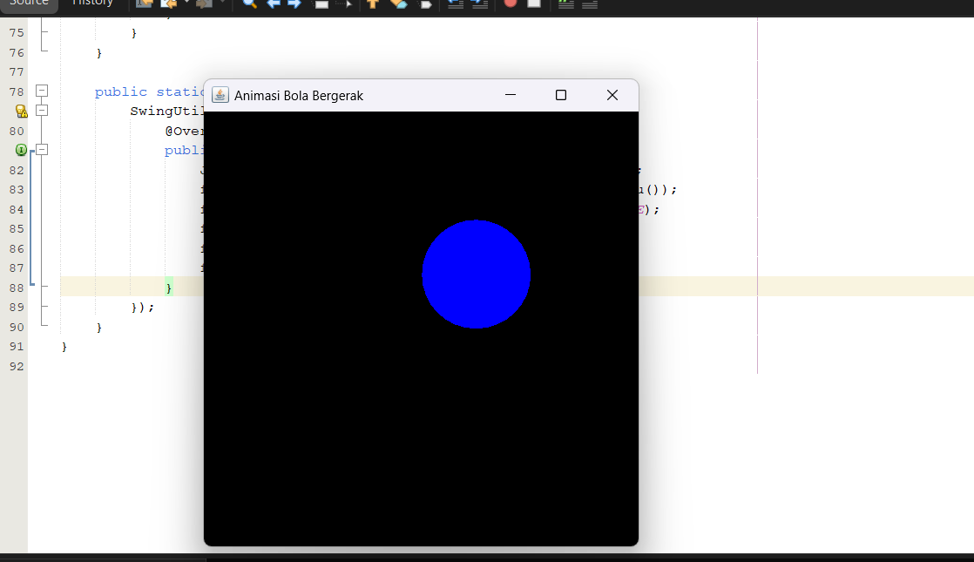

Program ini membuat animasi lingkaran bergerak dari atas ke bawah

TUGAS

/*

* Click nbfs://nbhost/SystemFileSystem/Templates/Licenses/license-default.txt to change this license

* Click nbfs://nbhost/SystemFileSystem/Templates/Classes/Class.java to edit this template

*/

package bp1_m5_bayu;

import java.awt.Color;

import java.awt.Dimension;

import java.awt.Graphics;

import java.awt.event.ActionEvent;

import java.awt.event.ActionListener;

import java.util.ArrayList;

import java.util.List;

import javax.swing.JFrame;

import javax.swing.JPanel;

import javax.swing.SwingUtilities;

import javax.swing.Timer;

public class BP1_M5_Tugas_Bayu extends JPanel {

private static final int L = 400, T = 400;

private List<Bola> bola;

public BP1_M5_Tugas_Bayu() {

setBackground(Color.BLACK);

setLayout(null);

bola = new ArrayList<>();

bola.add(new Bola(0, 0, 9, 10)); //posisi awal bola dengan kecepatan awal

Timer timer = new Timer(28, new ActionListener() {

@Override

public void actionPerformed(ActionEvent e) {

for (Bola b : bola) {

b.Bergerak();

}

repaint();

}

});

timer.start();

}

@Override

protected void paintComponent(Graphics g) {

super.paintComponent(g);

for (Bola b : bola) {

b.GambarBola(g);

}

}

@Override

public Dimension getPreferredSize() {

return new Dimension(L, T);

}

private static class Bola {

private static final int DIAMETER = 50; //ukuran bola

private int x, y;

private int dx, dy;

public Bola(int x, int y, int dx, int dy) {

this.x = x;

this.y = y;

this.dx = dx;

this.dy = dy;

}

public void GambarBola(Graphics g) {

g.setColor(Color.GREEN);

g.fillOval(x, y, DIAMETER, DIAMETER);

}

public void Bergerak() {

//gerakan horizontal

x += dx;

if (x <= 0 || x + DIAMETER >= L) {

dx = -dx;

}

//gerakan vertikal

y += dy;

if (y <= 0 || y + DIAMETER >= T) {

dy = -dy;

}

}

}

public static void main(String[] args) {

SwingUtilities.invokeLater(new Runnable() {

@Override

public void run() {

JFrame frame = new JFrame("vertical horizontal");

frame.getContentPane().add(new BP1_M5_Tugas_Bayu());

frame.setDefaultCloseOperation(JFrame.EXIT_ON_CLOSE);

frame.pack();

frame.setLocationRelativeTo(null);

frame.setVisible(true);

}

});

}

}

